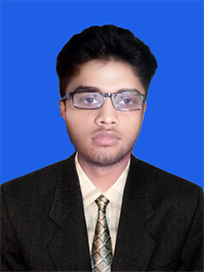

Passport Size Photograph

**Masud Parbhez**

E-mail: masud.affb@gmail.com

Mobile: +08801632214506

Objective

To face challenges using knowledge, perception and innovation to pursue long term success career in dynamic and professional environment of any organization through my aptitude, hard work, dedication and determination.

Education:

|  |  |  |  |
| --- | --- | --- | --- |
| Name of education | Result | Passing Year | Institution |
| Diploma Engineering(Computer Technology) | 3.72 | 2017 | Institute of Computer Science and Technology |
| S.S.C | 4.44 | 2013 | Dharmapur Educational Estate |

**Computer/Technical Skills**

□ Basic Computer Knowledge (Fundamental Of Computer)

□ Microsoft Office Program (M.S-word, Excel, Power-Point, Access)

□ Operating System Windows-Xp, 2007, 2008 &2010)

□ Have good knowledge in computer hardware, software & internet application

□ Also work with Adobe Photoshop and Illustrator

**Language Skills:**

Bengali, English and Hindi

Strength:

Strong leadership skills.

Ambitious and target oriented.

**Personal Interest:**

Reading books, Newspaper, Magazines.

Playing cricket, Football, Badminton.

Watching movies,

**Personal information:**

Father’s Name : Rafiqul Islam

Mother’s Name : Khodeza Begum

Present Address : Shanti company road, Feni.

Permanent Address: Do

Marital Status : Single

Date of Birth : 01/02/1996

Nationality : Bangladeshi

Religion : Islam

Height : 5’2”

Blood Group : AB+ (Positive)

**References:**

|  |  |
| --- | --- |
| 1. Ziaul Haque  Head of Computer Science Department  Institute of Computer Science and technology.  Cell: +01753446211 | 2. MD. Asaduzzaman  Instructor and Director  Compact Polytechnic institute.  Cell: +8801710569153 |

Respectfully yours

Masud Parbhez

Date: 21/02/2018